Event Management

LogIn:-

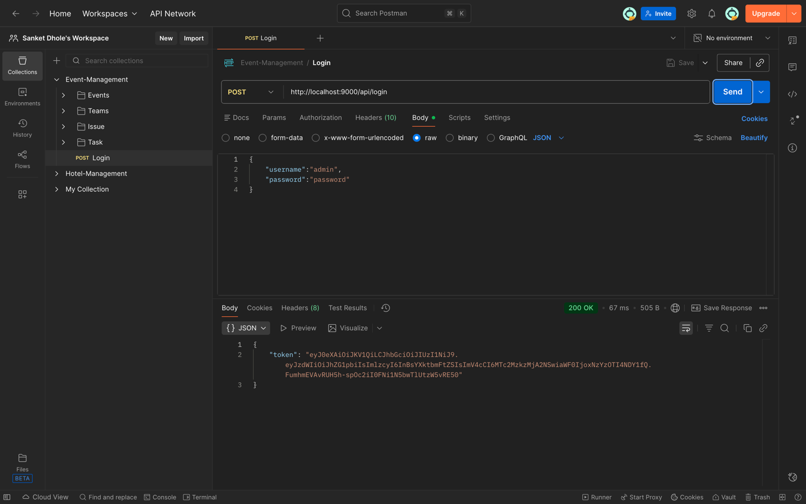

Teams:-

1. Create:-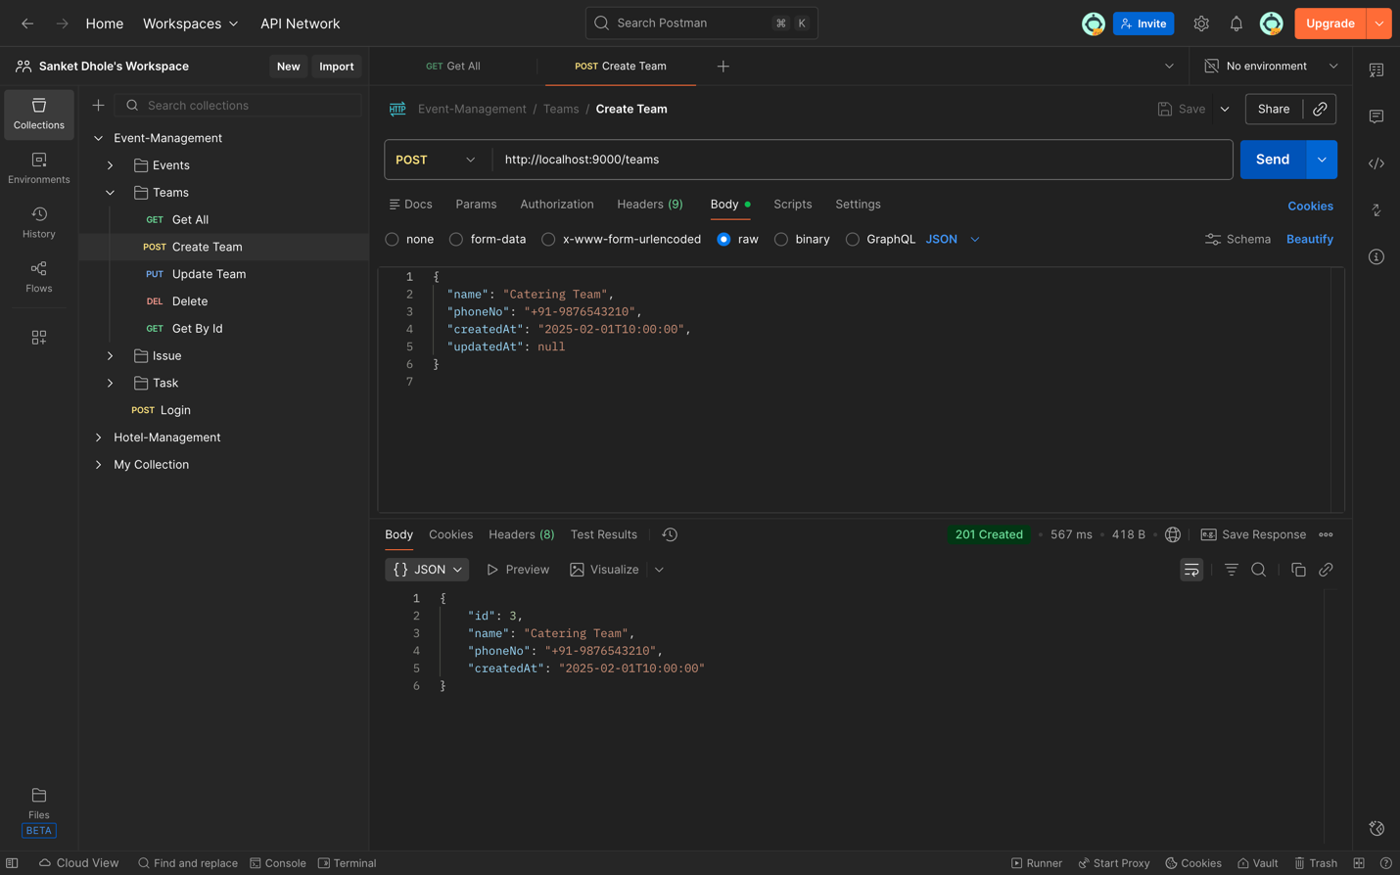
2. Update Team:-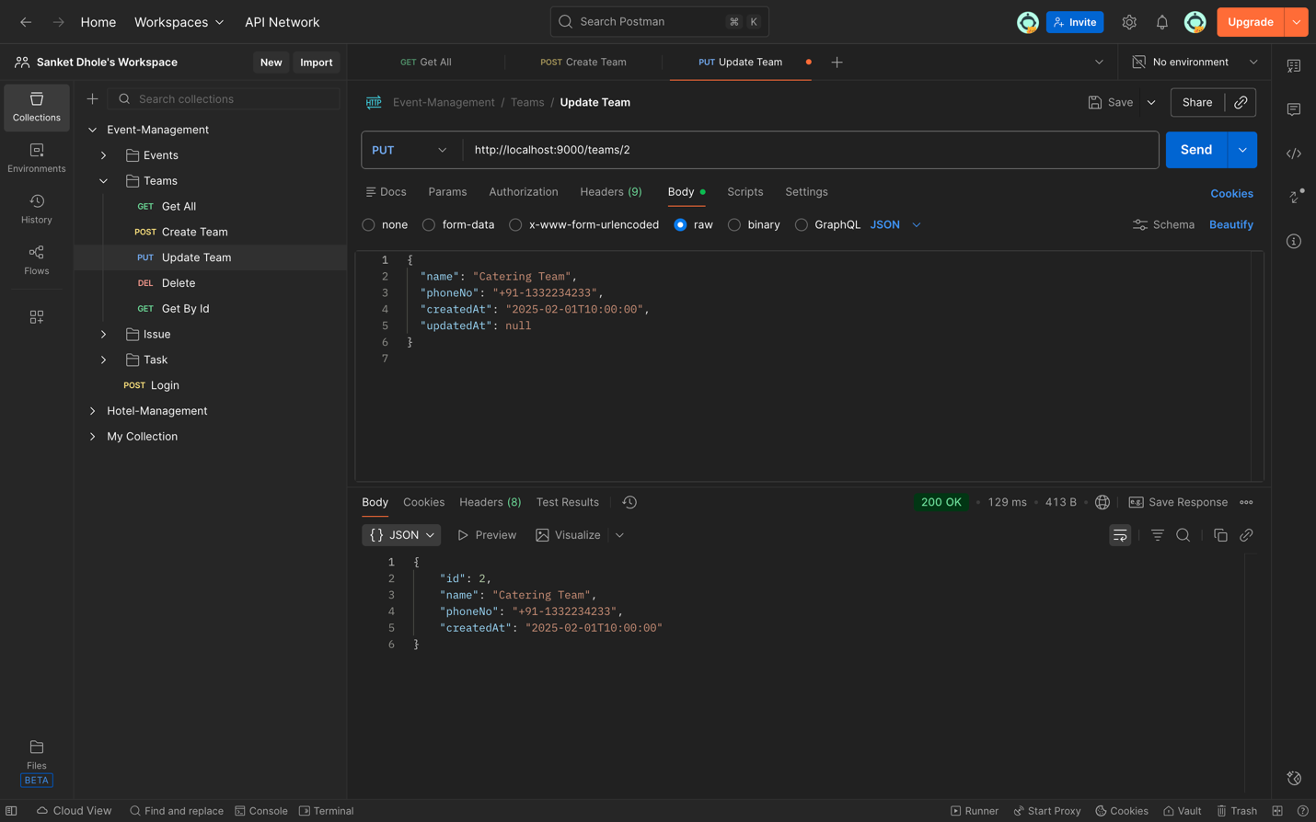
3. Get All Teams:-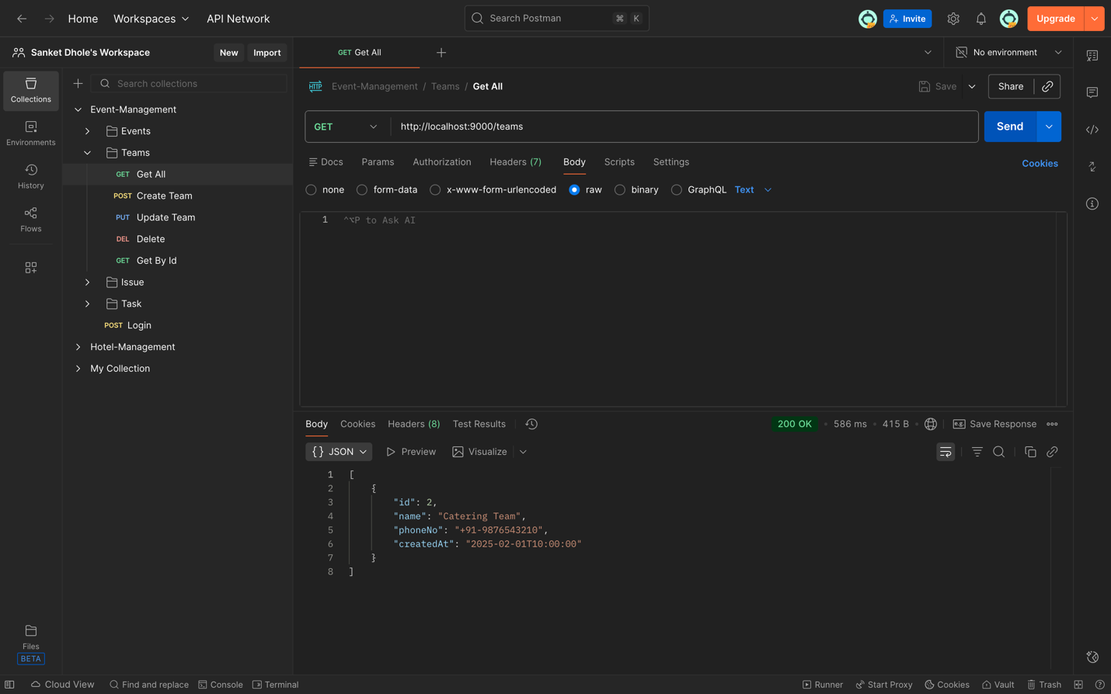
4. Get Team By Id:-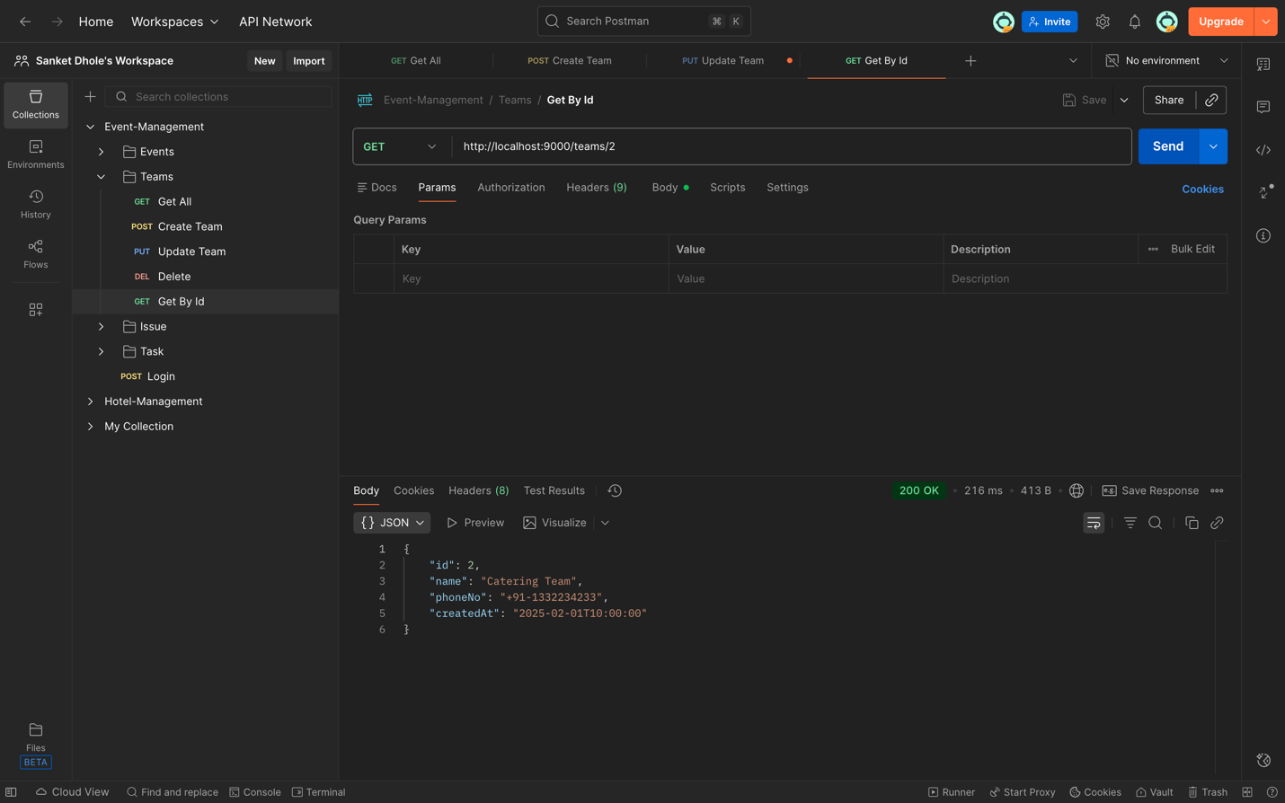

Events:-

1. Create event:-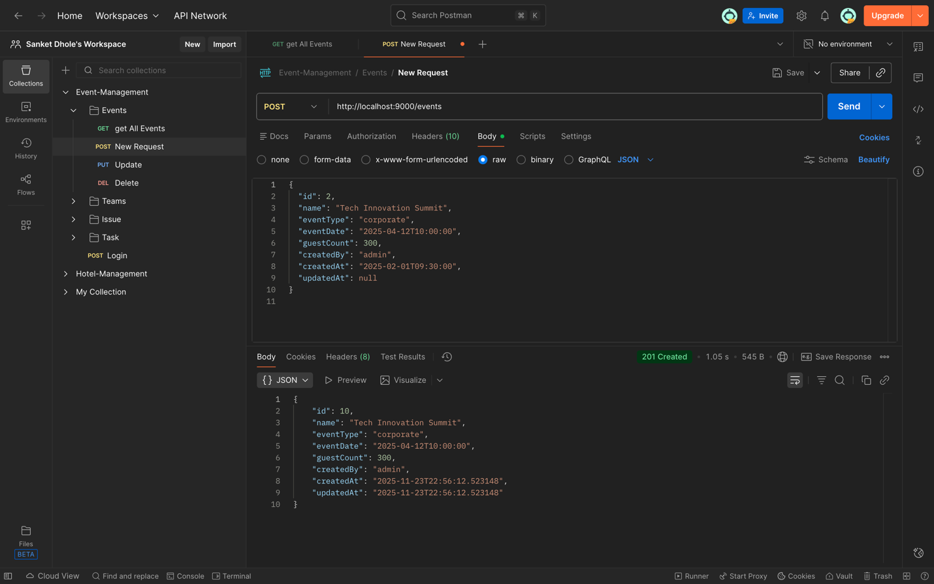Consumer Output:-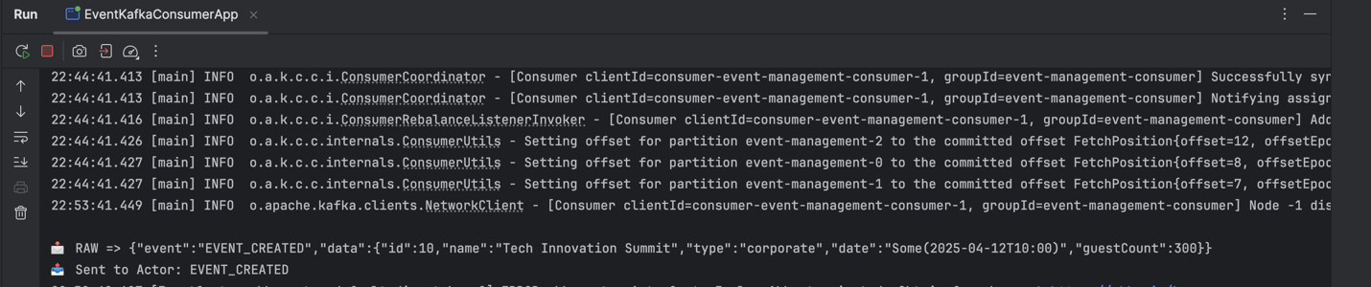
2. Edit Event:-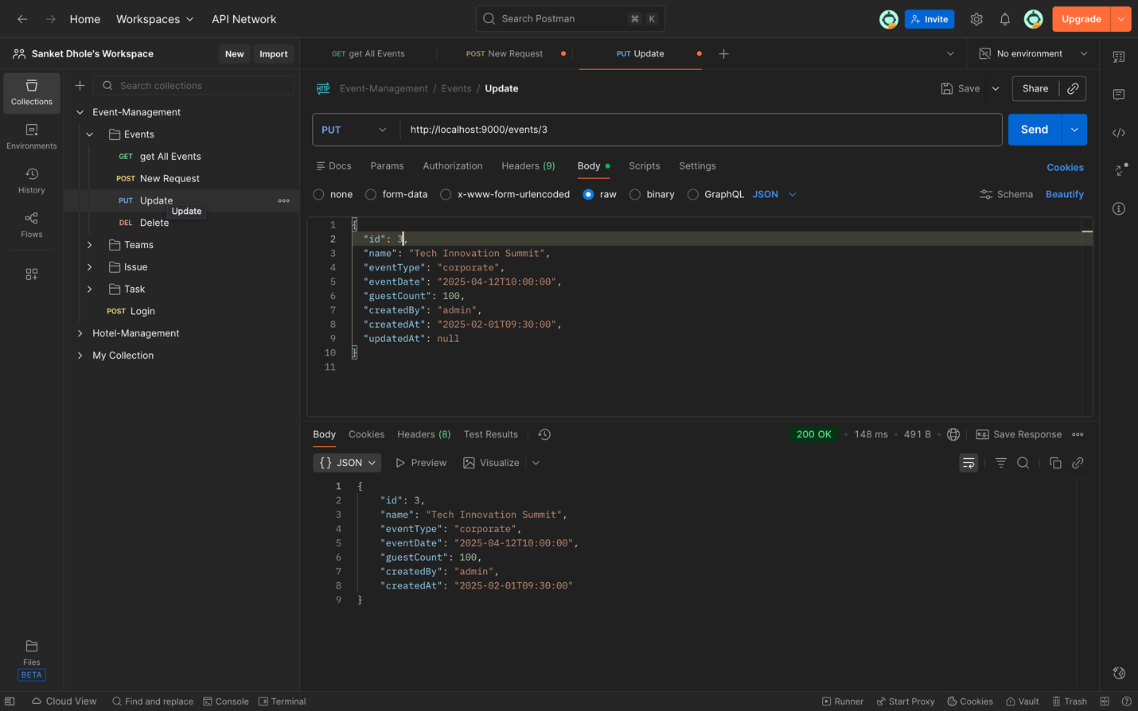
3. Get All Events:-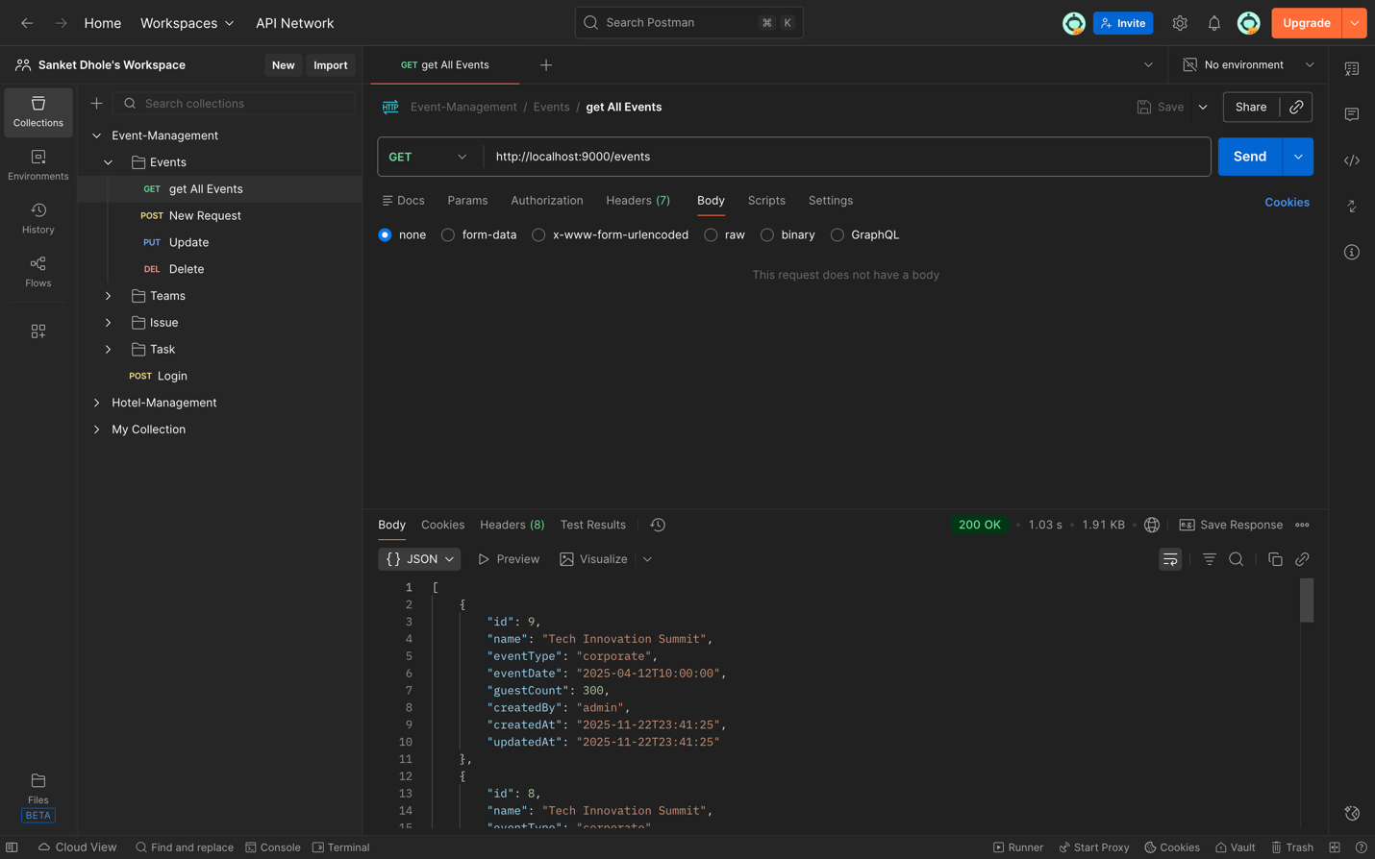

Tasks:-

1. Create Task:-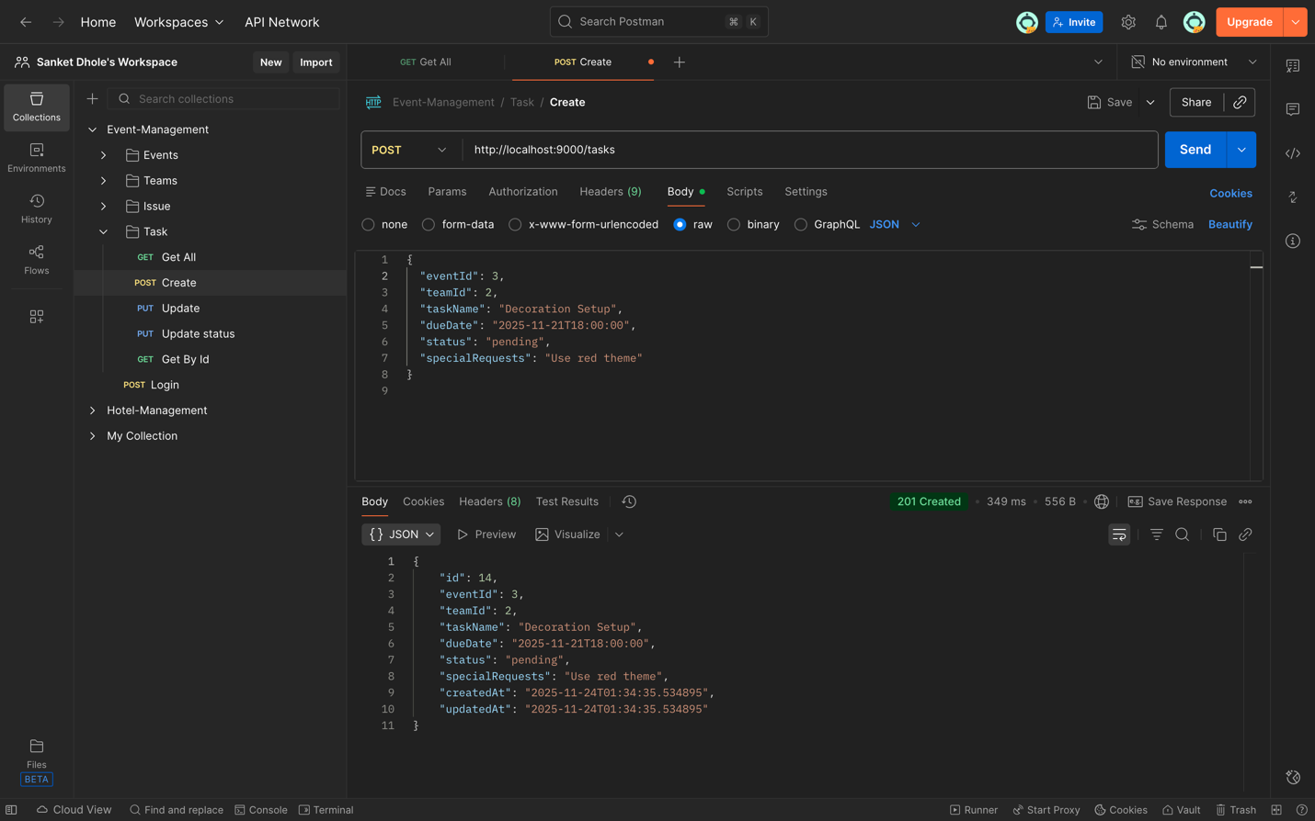Create Task Producer Output:-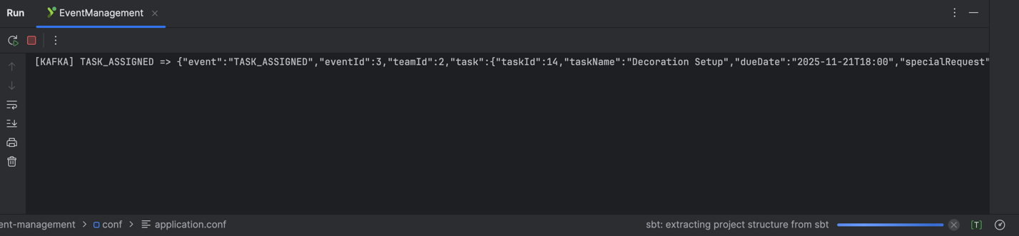Create Task Consumer Output:-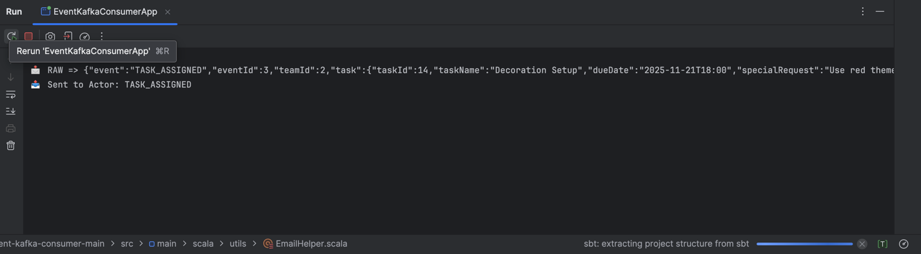
2. Get All Task:-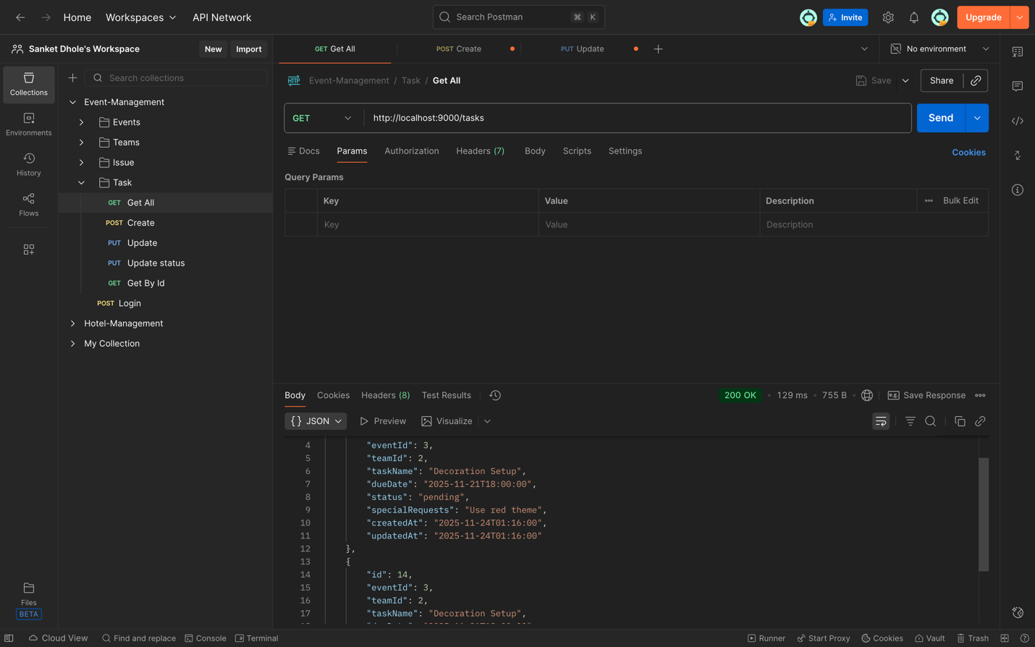
3. Update Task:-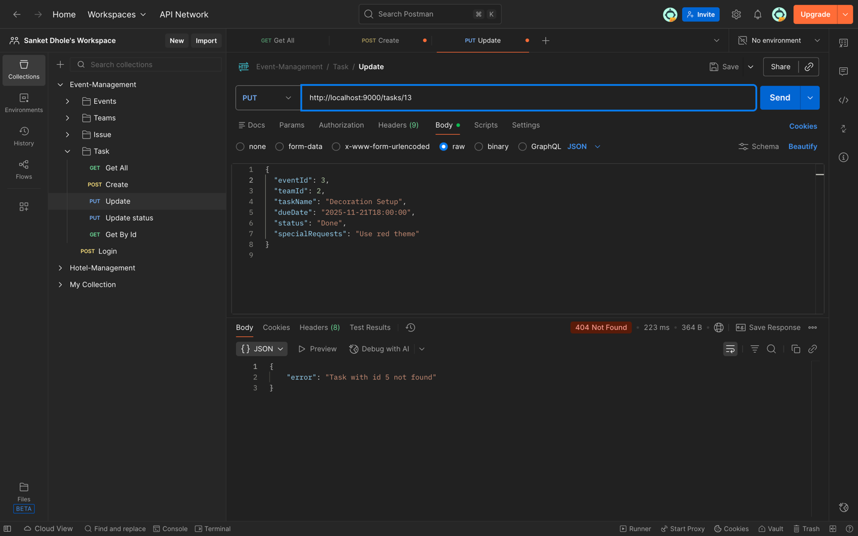
4. Task Get By Id :-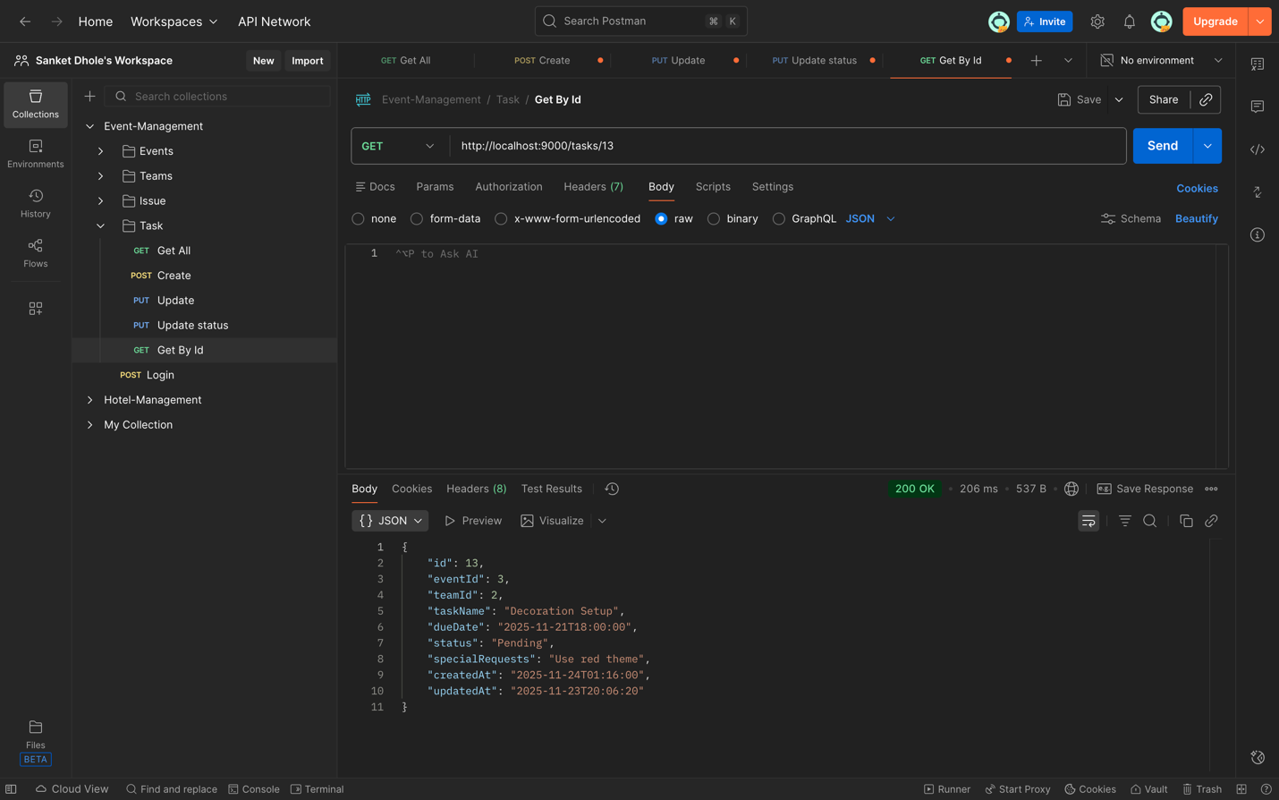
5. Update Status:-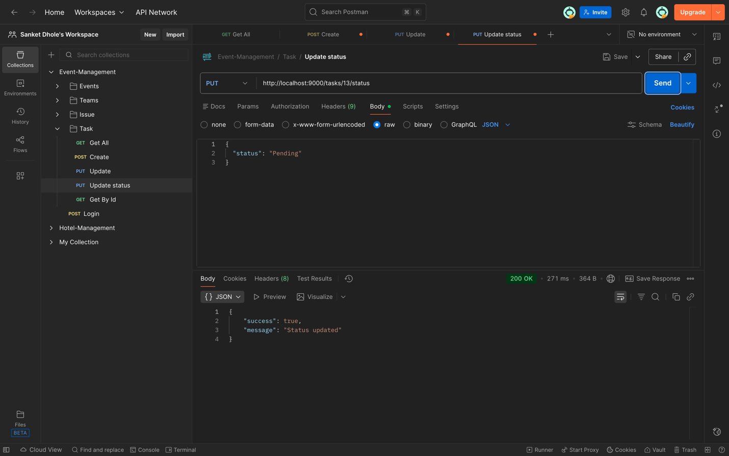Update Status Producer Output:-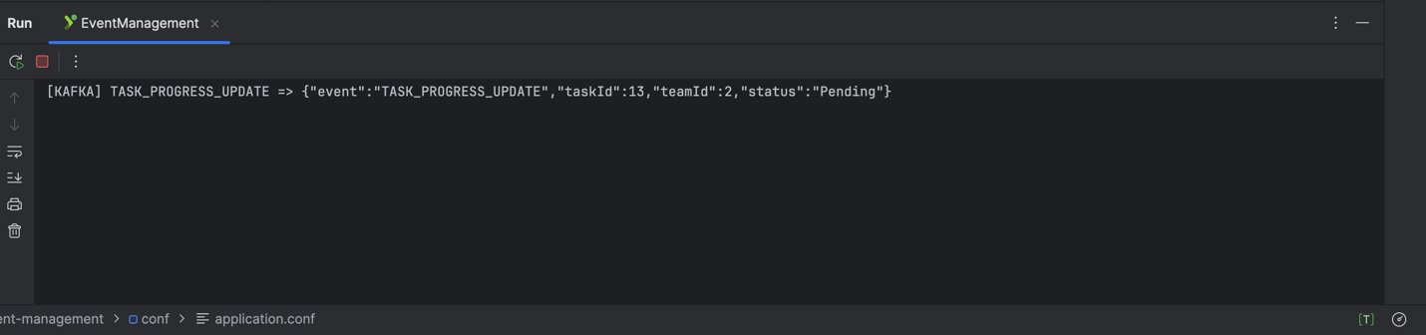Update Status Consumer Output:-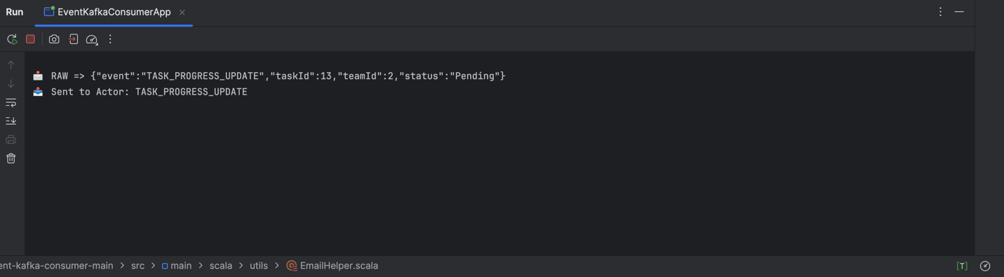

MySQL Tables:-

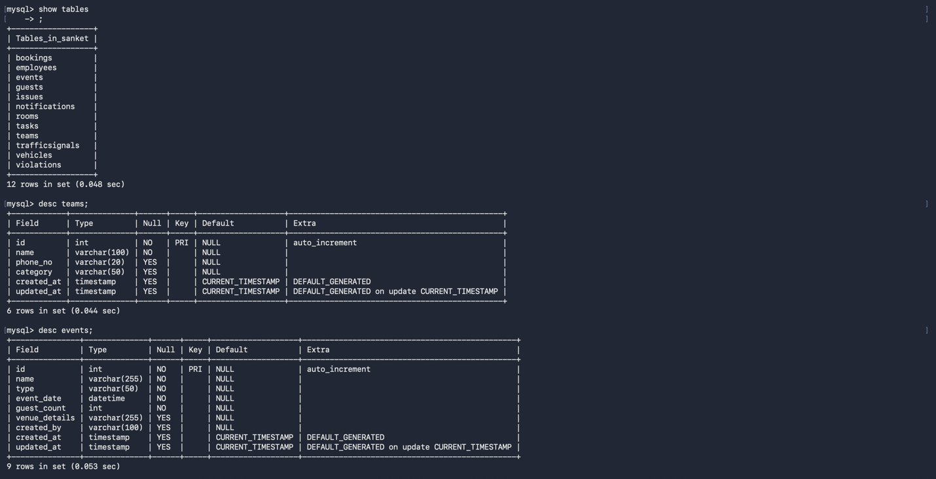

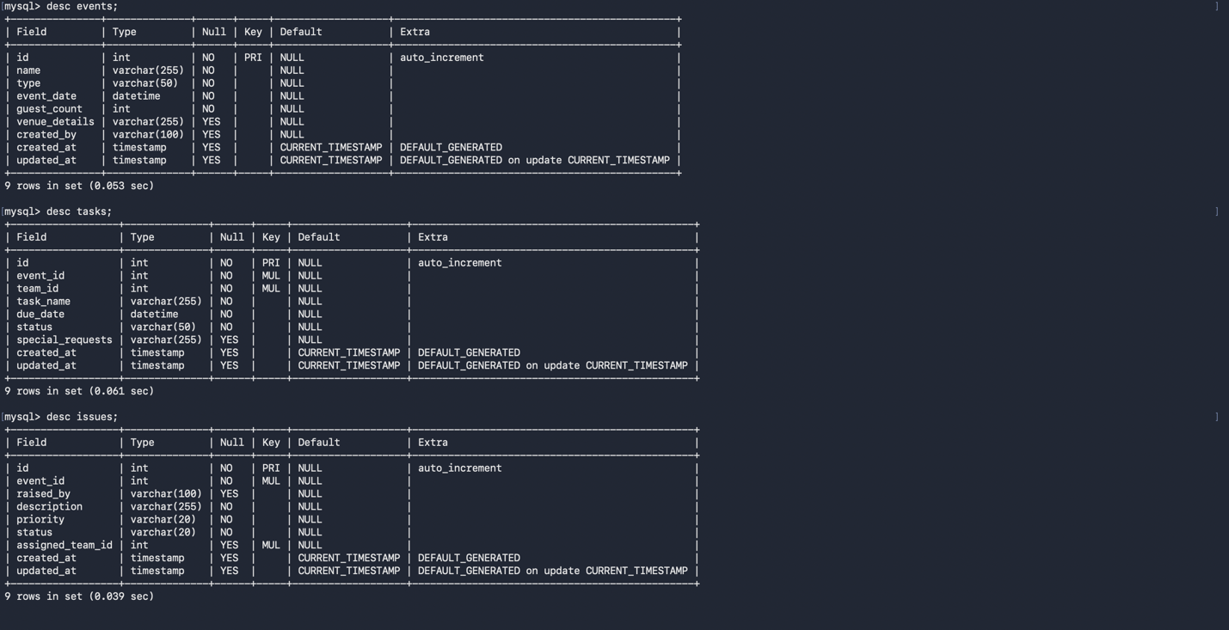

1. Teams:-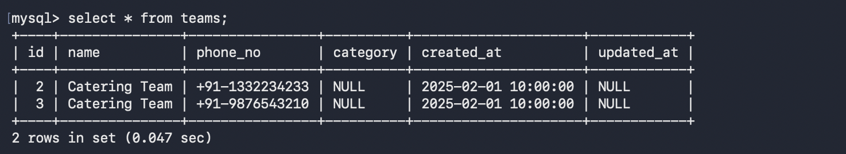
2. Events:-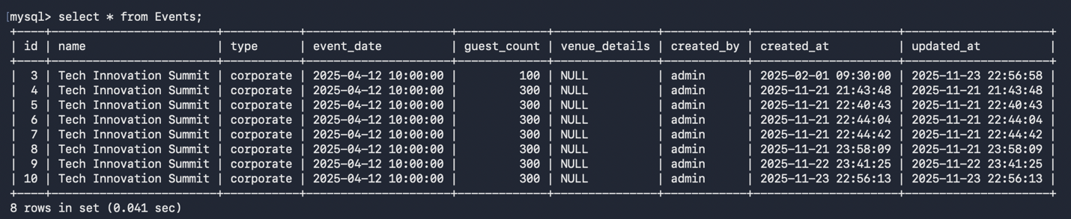
3. Tasks:-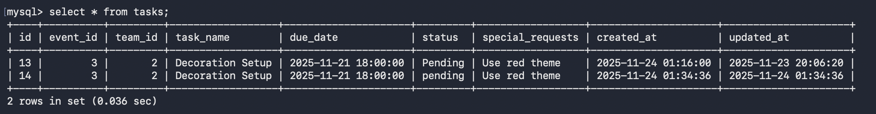
4. Issues:-